• CIVIL WORKS IN 0PD BLOCK
• CIVIL WORKS IN /PD BLOCK
• PAYMENT PLAN SCHEDULE
STELLA

OBASANJO HOSPITAL
Edo state ministry of Health

PROGRESS REPORT: WEEK 7 (13th - 18th February 2023)


TANIT MEDICAL ENGINEERING February 2023
Civil works in OPD block

% PERCENTAGE COMPLETION
14, February 2023

45.8%
110%

100%

90%

80%

70%

60%

. ... I
I

94%

100%
ONGOING WEEK 7 ACTIVITIES

Plastering of internal & external walls [ 70% 50%

Casting of parapet wall I 100% 40% 35%
II

MEPF first fix [ 61.1% 30% Primer painting I 12.90% 20% Hydrotherapy pool pump house wall I 5% 10%

0%
53% II
II
II
II
II
II II
II
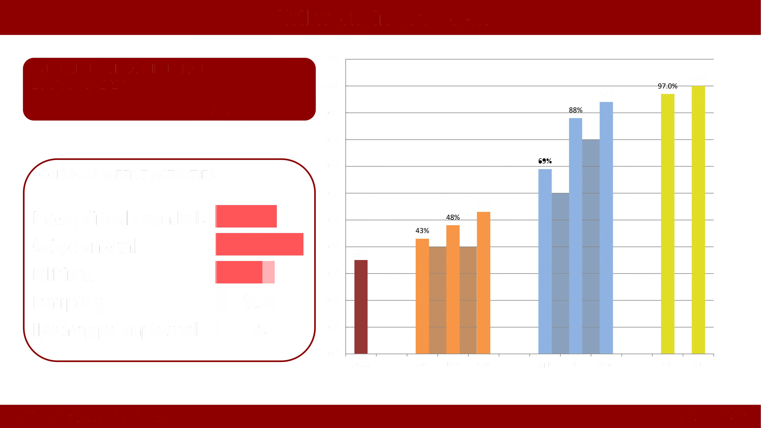2022 Jan Feb Mar Apr May June July Aug
II

TANIT MEDICAL ENGINEERING February 2023
Civil works in IPD block

% PERCENTAGE COMPLETION
14, February 2023
110%

100%
0.75% 92%
90%

ONGOING ACTIVITIES

• NIL
80%

70%

60%

50%

40%

75%

PREVIOUS ACTIVITIES IN IPD
• Removal of suspended ceiling
• Removal of sanitary wares
• Removal Air-conditioners
All item carefully accounted for and stored in container on site
30%

20%

10%

0%

0%

2022

0%

Jan Feb Mar Apr May June July Aug Sept Oct Nov
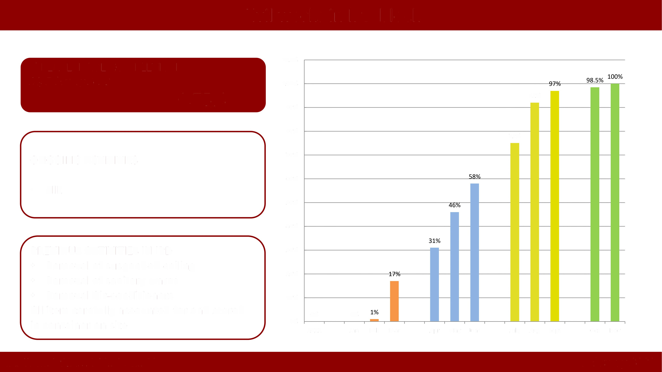

TANIT MEDICAL ENGINEERING February 2023
Contractors Payment Plan Schedule

Contractors Payment plan

• Sudabelt Medical Equipment limited
LOT1 (MEDICAL EQUIPMENT)
N1,625,778,150.00

• Sudabelt Medical Equipment limited LOT2 (RADIOLOGY) N2,104,552,000.00

1. 50% mobilization payment on all 3 LOTs

2. 20% Advance payment after 30days for LOT1 & LOTS

3. 20% Advance payment after 60 days from date of first mobilization for
LOT2

4. 20% Advance payment after 4 months from initial mobilization for LOT1 &
LOTS

• Sudabelt Medical Equipment limited
LOTS (IVF & LAB)
N1,090,041,596.00
5. 10% Advance payment after 5 months from initial payment for LOT1 & LOTS upon completion of installation and 20% for LOT2 upon provision of packing list and associated shipping documents from OEM.

6. Balance payment of 10% after 6 months from initial payment upon delivery and installation of LOT2


TANIT MEDICAL ENGINEERING February 2023
Contractors Payment Plan Schedule

Contractors Payment plan

1. 60% mobilization payment on LOT3

• Supreme Meditech
LOT3 Medical
{MEDICAL GASES) N648,989,222.31
2. 20% Advance payment after 30 days

3.15% Advance payment after 4 months from mobilization

4. Balance payment of 5% upon delivery for LOT3 after 7 months from initial payment

1. 50% mobilization on LOT3

• BlueHub
LOT3 Non-medical
{IT & APPLIANCES) N105,440,181.75

2. 30% Advance payment, 4 months after mobilization upon delivery and inspection of goods in the warehouse

3. Balance payment of 20%, 6 months from initial mobilization subject to completion of installation
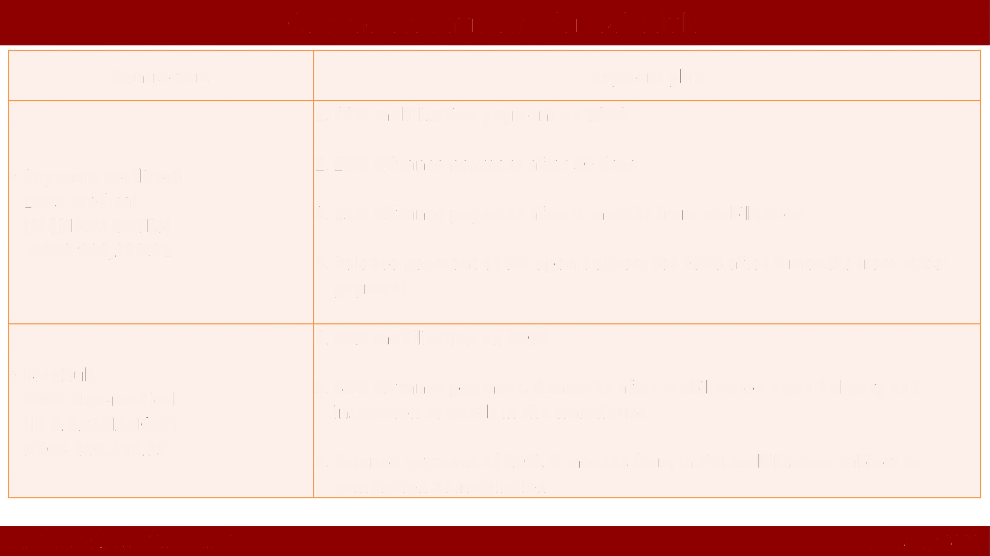

TANIT MEDICAL ENGINEERING February 2023
Contractors Payment Plan Schedule

Contractors Payment plan

1. 60% mobilization

• Reedpriceman LOT2 Non-medical (OFFICE FURNITURE) N409,710,761.75

2. 20% Advance payment after 60 days from initial mobilization, and upon inspection of goods in the warehouse

3. Balance payment of 20% upon installation after 4 months from initial mobilization

• Sabtrak Limited
LOT 1 Non-medical (OFFICE APPLIANCE) N14,850,609.00
1. 10% mobilization

2. 60% advance payment after 4 months from mobilization, and upon inspection of goods in the warehouse and delivery to site.

3. Balance payment of 30% upon installation, 5 months after mobilization.


TANIT MEDICAL ENGINEERING February 2023
Contractors Payment Plan Schedule

LOT
Number Description Supplier
30• 01•
Month 15-Feb-23 15-Mar-23 30-Apr-23 May-23 Jun-23 01-Jul-23 01-Aug-23 01-Sep-23 01-Oct-23 LOT TOTALS PHASE 1

MEDICAL EQUIPMENT SUDABELT MEDICAL 162,577,815.0
LOT1 COMPANYLTD 812,889,075.00 325,155,630.00 - - - 325,155,630.00 0 - - 1,625,778,150.00

RADIOLOGY SUDABELT MEDICAL 1,052,276,000.0 420,910,400.0
LOT2 COMPANYLTD 0 - 420,910,400.00 - - - 0 210,455,200.00 - 2,104,552,000.00

LABORATORY & IVF SUDABELT MEDICAL 109,004,159.6
LOTS COMPANYLTD 545,020,798.00 218,008,319.20 - - - 218,008,319.20 0 - - 1,090,041,596.00
MEDICAL GASES AND SUPREME MEDITECH
LOT3 PLANT LTD 389,393,533.39 129,797,844.46 - - - 97,348,383.35 - - 32,449,461.12 648,989,222.31
LOT6
I1./ AUDIOVISUAL
(PART) BLUEHUBLTD 52,720,090.88 - - - - 31,632,054.53 - 21,088,036.35 - 105,440,181.75
LOT6

(PART) LOT6
FURNITURE

APPLIANCES

REED PRICEMAN LTD 245,826,457.05 .
81,942,152.35 | - - 81,942,152.35 | - | - | - | 409,710,761.75

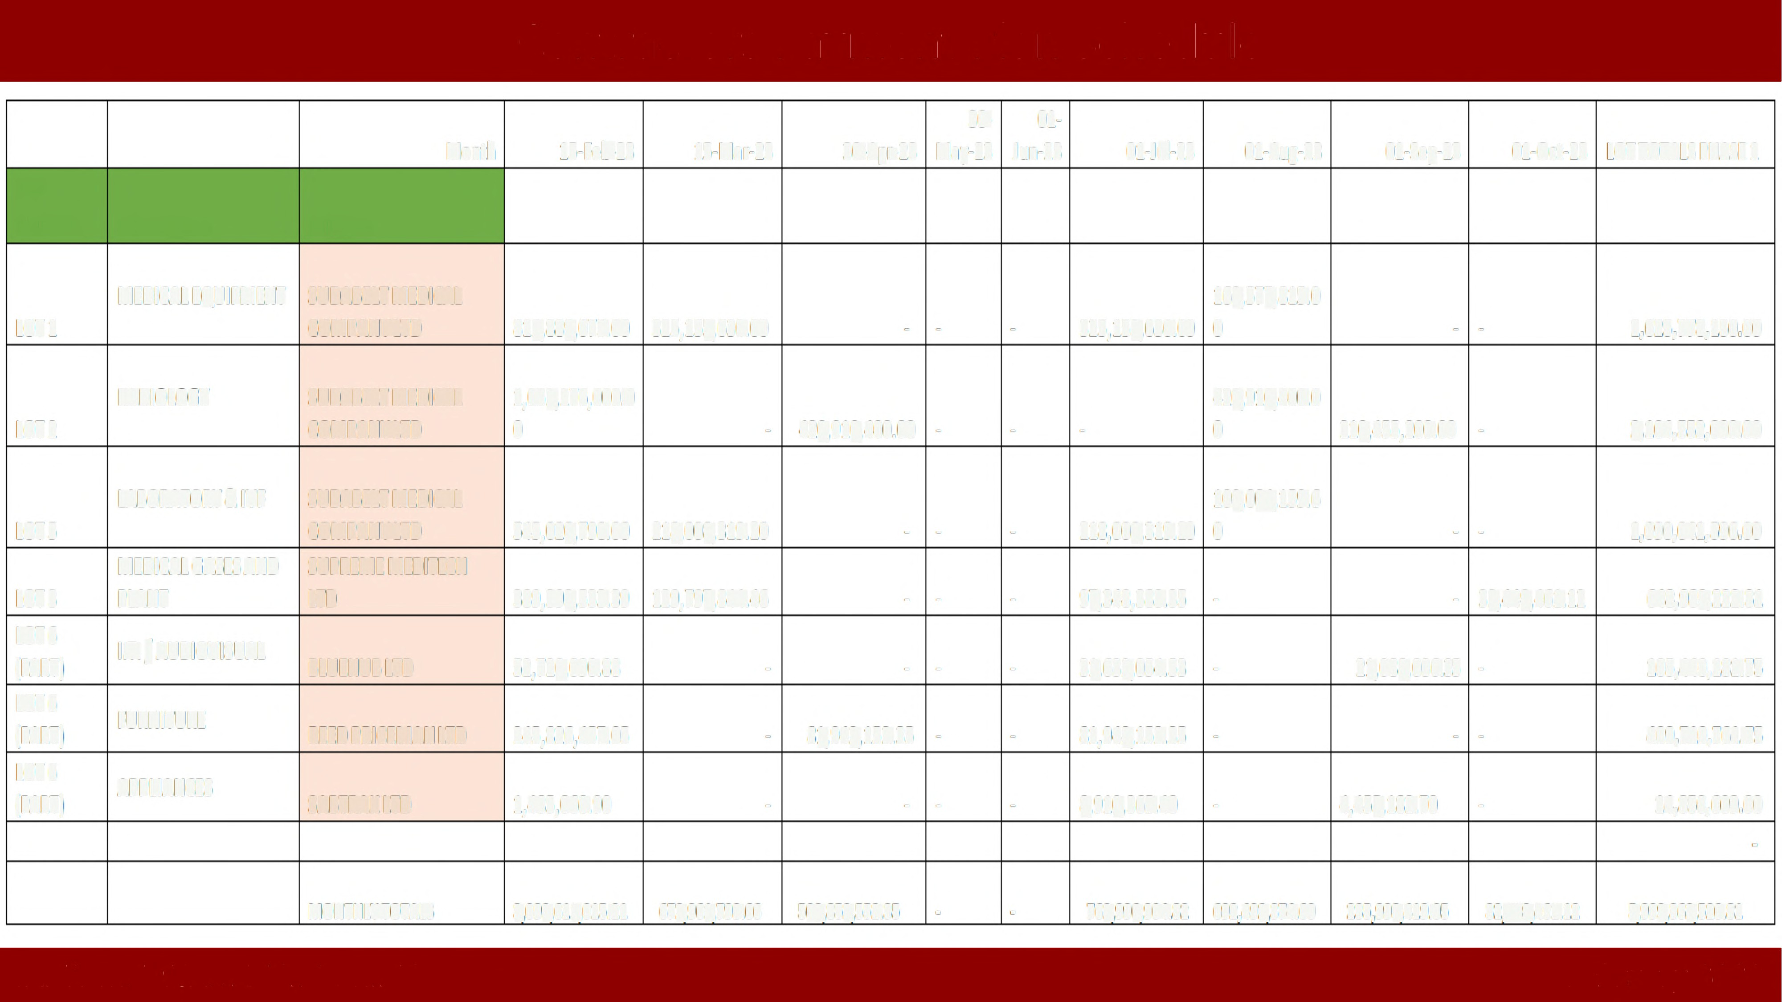(PART) SABTRAKLTD 1,485,060.90 - - - - 8,910,365.40 - 4,455,182.70 - 14,850,609.00
.

MONTHLYTOTALS 3,099,611,015.21 672,961,793.66 502,852,552.35 . . 762,996,904.82 692,492,374.60 235,998,419.05 32,449,461.12 5,999,362,520.81

TANIT MEDICAL ENGINEERING February 2023

